churnall = read.csv('C:/temp/churn_data.csv',header = TRUE)

churn1 = subset(churnall, churnall$churn == 1)

library(ggplot2)

ggplot(churn1, aes(x = age)) +

+ geom_histogram(aes(y = ..count..), binwidth = 5)

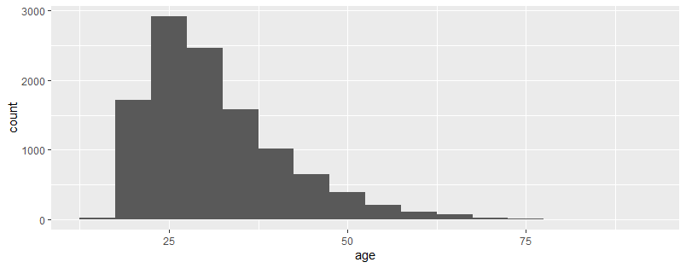

Should target 25-35 year old – they have the highest churn

churn2535= subset(churn1, churn1$age > 25 & churn1$age < 36)

ggplot(data=churn2535,aes(x=age,y=purchases )) + geom_bar(stat="identity")

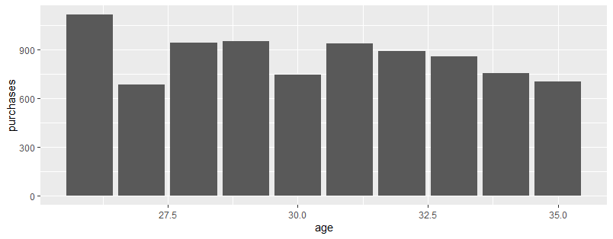

Purchased less than $1000

ggplot(data=churn2535,aes(x=rewards_earned,y=reward_rate)) + geom_point()

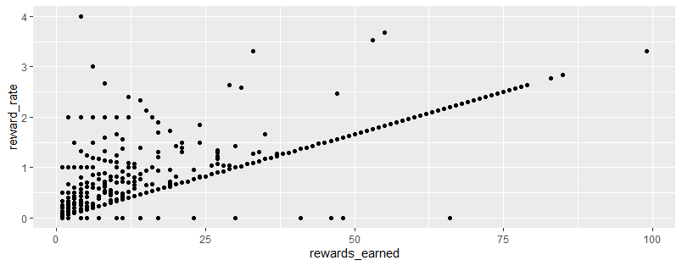

Showing bulk of rewards earned quite low due to low reward rate

churn2535 <- churn2535 %>%

mutate(

user_type = case_when(web_user == 1 ~ 'web',

app_web_user == 1 ~ 'app_web',

ios_user == 1 ~ 'ios',

android_user == 1 ~ 'andriod',

TRUE ~ 'NA')

)

ggplot(data=churn2535,aes(x=user_type,y=purchases )) + geom_bar(stat="identity")

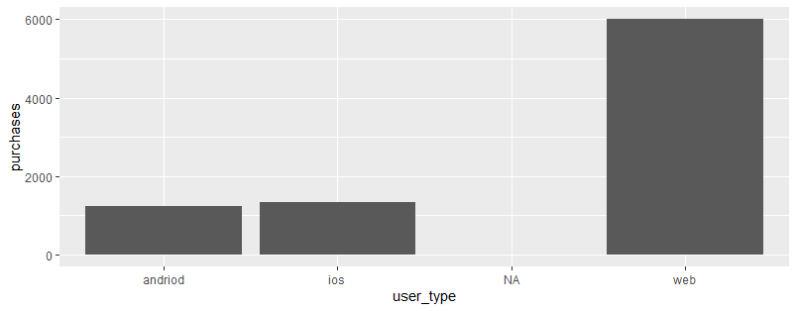

Low update on phones